MATHEUS DANTAS VIEIRA

PROTOTIPAÇÃO APP COVID (ENGENHARIA DE SOFTWARE)
https://www.figma.com/file/zOEB52YeD8esxWyH41Qg5v/P%C3%A1gina-1?node-id=0%3A1
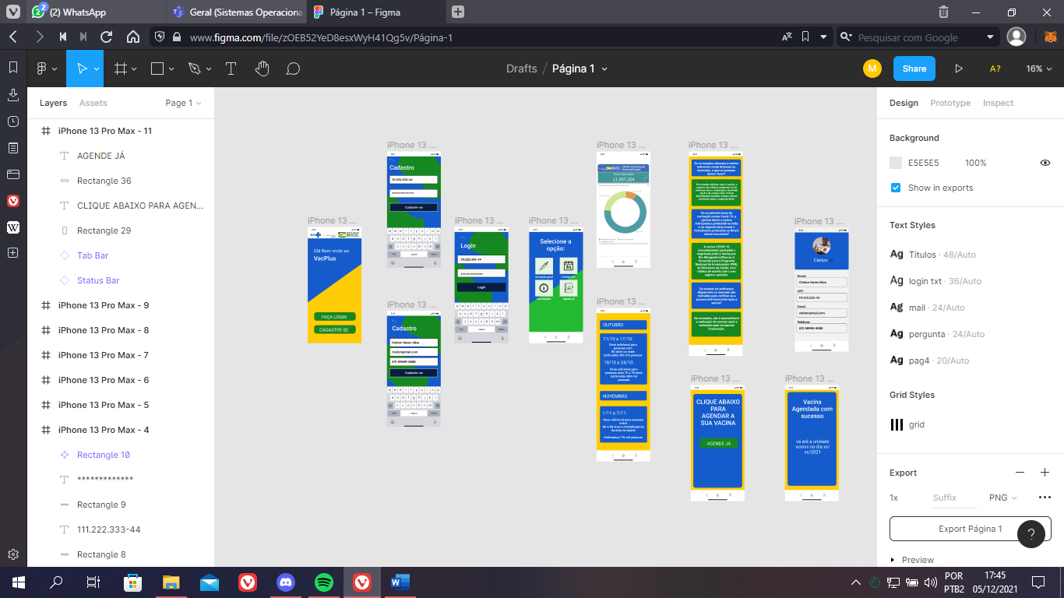

SCRUM
https://trello.com/invite/b/sPo6I4MR/29e579306a4d4563d2a65333c4a9671f/vacplus
